The ultimate guide to php artisan tinker

Sebastian Schlein

What is tinker?
This post is dedicated to an underappreciated component of Laravel – the tinker command that you can run with php artisan tinker. The command is built into every Laravel application and you can use it to run code within the context of your application. Let's explore what this means.
Tinker is a REPL (read-eval-print loop) on top of PsySH. It takes your command line input, evaluates it and prints the output to the console. So instead of using your database management tool and writing an SQL query to get the amount of users in your database, you can simply run App\User::count() and get => 10 as the result.

Tinkerwell –
the tinker IDE
The must-have tinker tool for the smart PHP and Laravel developer. Get instant feedback while you type and run multi-line commands with ease.
Learn more

How does it work?
The php artisan tinker command bootstraps your application and waits for new commands when this finishes. It keeps the application state until you close leave the tinker command with exit, Ctrl+C or close the terminal. This means that you have to initialize a new tinker session every time you change your code to get the latest version – but it allows you to define new variables that are accessible until you end the tinker session.

When do you need it?
All the time! We use tinker in development and on production for many scenarios. The most common use case is accessing the database via Laravel Eloquent Models.

Use Eloquent Models with tinker
Tinker is very convenient if you want to create test data in development – simply create two new test users with their factory.
User::factory()->count(2)->create()
This command uses the model factory for users and creates two new users. Your output of this command should look similar to this – with different usernames and emails.
=> Illuminate\Database\Eloquent\Collection {#4612
all: [
App\Models\User {#4616
gender: "male",
firstname: "Orie",
lastname: "Rath",
email: "jocelyn.schuster@example.org",
},
App\Models\User {#4620
gender: "female",
firstname: "Karlie",
lastname: "Ruecker",
email: "trycia.koelpin@example.org",
},
],
}
Let's change the last name of the second user with php artisan tinker (type and confirm every line separately)
$user = User::where('email', 'trycia.koelpin@example.org')->first();
$user->lastname = 'Smith';
$user->save();
If this works, tinker returns => true
If you don't want to run multiple commands and the model supports mass assignments, you can run this in a single line.
User::where('email', 'trycia.koelpin@example.org')->first()->update(['lastname' => 'Carlson']);
There are no limits what you can do with tinker as long as you are able to squeeze your code into one line or can execute the code line by line. If you want to push this to the next level, you can use Tinkerwell to write multiple lines of code and run them at once. This is very handy if you work with Laravel Collections or use loops – or simply like well-formatted code.
With tinker, you have access to all PHP functions and helpers that Laravel provides.

Generate UUIDs
Instead of googling for an internet service that lets your generate UUIDs, you can use tinker and generate one with the Laravel Str helper.
Str::uuid()
This instantly generates an UUID for you.
=> Ramsey\Uuid\Lazy\LazyUuidFromString {#4632
uuid: "a1d56de1-455d-4275-8812-c3e28d45428e",
}

Create a slug from a headline
Str::slug('The ultimate guide to php artisan tinker')
=> "the-ultimate-guide-to-php-artisan-tinker"

Get the date of the first day of the week in 3 months
now()->addMonths(3)->startOfWeek()
=> Illuminate\Support\Carbon @1627862400 {#5507
date: 2021-08-02 00:00:00.0 UTC (+00:00),
}

Base64 encode and decode
base64_encode('The ultimate guide to php artisan tinker')
base64_decode('VGhlIHVsdGltYXRlIGd1aWRlIHRvIHBocCBhcnRpc2FuIHRpbmtlcg==')
=> "VGhlIHVsdGltYXRlIGd1aWRlIHRvIHBocCBhcnRpc2FuIHRpbmtlcg=="
=> "The ultimate guide to php artisan tinker"
Ok, you get it.

Dispatch jobs
You can dispatch jobs with tinker and add data to this job too. This is a real time-saver when you develop a new job and there are multiple steps involved to trigger the job. Imagine that you have a job that fulfills an order in an ecommerce system. You can either place many orders to test the job or simply dispatch it via tinker. Remember to restart your tinker session if you change the code of the job.
$order = new Order(['invoice_id' => 12345, 'item' => 'Tinker Fangirl Mug']);
dispatch(new OrderPlacedJob($order));

Send Notifications
Similar to Jobs, you can also send Laravel Notifications & Mailables via tinker. You are in the context of your application and can send them with a simple call.
(new User)->notify(new InvoicePaid($invoice);

Check your current Laravel version
The composer.json file of your application contains the major and minor version of your Laravel application. If you want to know which Laravel version you use exactly, you can get this via app()->version().
app()->version()
=> "8.24.0"

Tinkerwell – php artisan tinker on steroids
Tinker is a powerful tool for all Laravel developers but you can push this to a next level. Tinkerwell is a code editor for macOS, Windows and Linux that is entirely dedicated to tinker. It comes with multiline support, SSH connections and allows you to tinker with multiple applications at the same time.
With Tinkerwell, there is no need to reload a tinker session, as Tinkerwell evaluates the current state of your code and does not keep the application state.

Using Collections
The multiline support makes it easy to use Laravel Collections or foreach loops in tinker. To continue with an example, you can update multiple users at the same time by using collections on the Eloquent result.
App\User::whereNull('confirmed_at')
->get()
->each(function ($user) {
$user->update([
'confirmed_at' => $user->created_at->addDay(),
]);
});

Testing APIs
When working with APIs, the Http facade of Laravel provides a fluent interface to send GET and POST requests to an API. You can use this to access the API and see how the data of this API looks or send data to the API before you implement the API directly in your application.
$apiKey = 'Your-Forge-API-Key';

$response = Http::withHeaders([
'accept' => 'application/json'
])
->withToken($apiKey)
->get('https://forge.laravel.com/api/v1/servers')
->json();

collect($response['servers'])->pluck('name');
=> Illuminate\Support\Collection {#1046
all: [
"HELO-cloud",
"bc-dev",
"bc-prod-01",
"bc-prod-02",
"bc-prod-03",
"bc-website",
"expose",
"expose-eu-1",
...
],
}
Tinkerwell is a mighty desktop application for every Laravel developer and more than 7,000 developers are already using Tinkerwell, including the Laravel team itself.
https://beyondco.de/blog/the-ultimate-guide-to-php-artisan-tinker

Laravel Tinker
Laravel Tinker allows you to interact with a database without creating the routes. Laravel tinker is used with a php artisan to create the objects or modify the data. The php artisan is a command-line interface that is available with a Laravel. Tinker is a command tool that works with a php artisan. A tinker plays around the database means that it allows you to create the objects, insert the data, etc.
- To enter the Tinker environment, run the command given below:
php artisan tinker
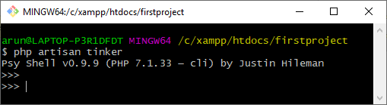
The above screen shows that the tinker environment has been created.

Creating data
- We can create the records in database tables by using the command-line tool. We use the following statement in the command-line tool that inserts the data directly in the database table:
$post=App\Post::create(['title'=>'Akshay','body'=>'akshay is a software developer']);
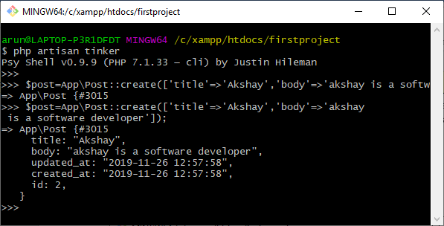
Output

When we execute the above statement, the data gets inserted in a posts table. We can view the inserted data in a phpMyAdmin shown in the below screenshot:
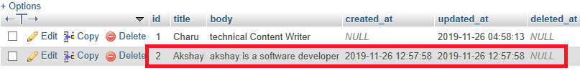
We can also use another way to insert the data by creating an object.
- First, we create the object.
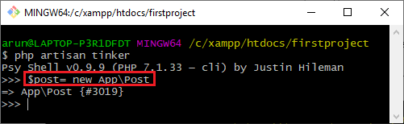
In the above screen, the highlighted line is creating the object, and the name of the object is $post. The $post is the object of the App\Post class.
We can also see whether the $post object has been successfully created or not of a given class by specifying the name of the object in a command-line tool.
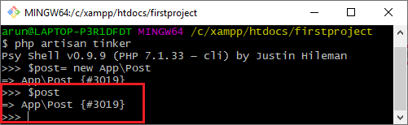
The above-highlighted area shows that the $post object has been successfully created as $post shows the name of the class, App\Post.
- After the creation of an object, we will insert the data with the help of an object.
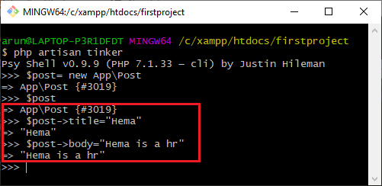
In the above screen, we have assigned the values to the column's title and body in a posts table by using the statements $post->title and $post->body, respectively. But, still, the data is not inserted in a table. To insert the data in the table, we need to use the statement given below:
$post->save(); // It saves the records in a database table.
When we type the $post in a command-line tool,

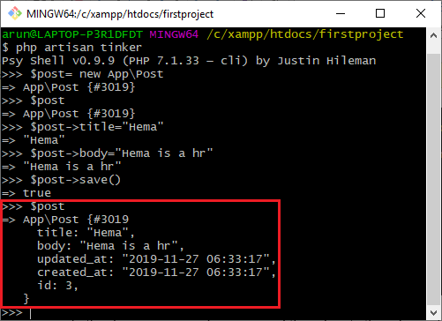
The above-highlighted area shows that the record is saved in a posts table
Let's look at the posts table in phpMyAdmin
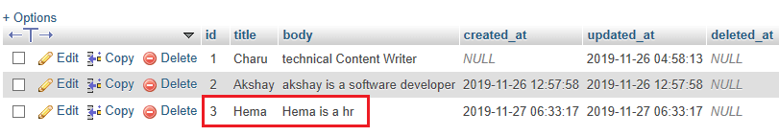

Finding Record
We can retrieve the records from the database in three ways:
- The first way is to use the find() method.
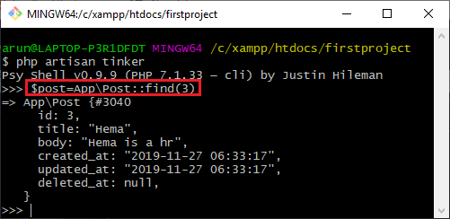
- The second way is to use the constraint, i.e., where clause.
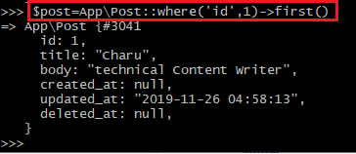
In the above screen, we are retrieving the record, which is having an 'id' equal to 1. In this case, we use the first() method as the first() method is used to retrieve the single record.
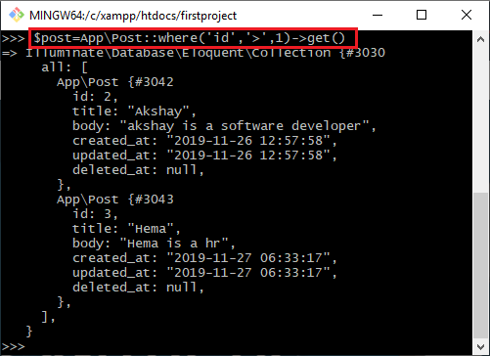
In the above screen, we are retrieving the records having an id greater than 1. In this case, more than one record is fetched, so we use the get() method. As get() method is used when an array of records is retrieved.

- The third way is to use whereId().
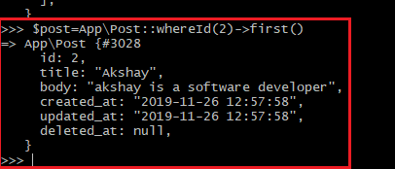

Updating data
In this section, we will learn how to update the data in a database.
Let's understand through an example.
- First, we find out the object which we want to update.
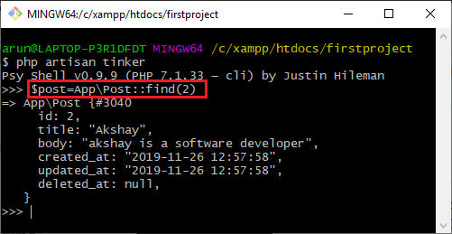
In the above screen, we have retrieved the second record and stored in a $post object.

- Now we update the values of two columns, title, and body.
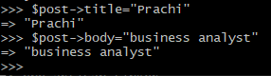
- To save the record in a database, we use the save() method.
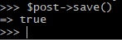
In the above screen, the save() method returns true, which means that the record has been successfully updated in a database.
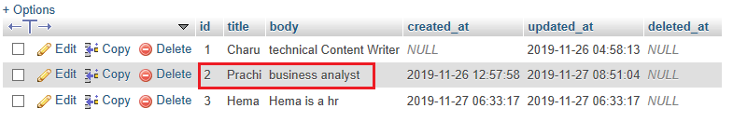

Deleting data
Now, we will see how to delete the data from the database table.
Let's understand through an example.
- As we know that $post is an object that contains the second record, first, we apply the delete() on the $post object.
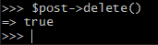
The above screen shows that the delete() method returns true value, which means that the record has been deleted.
- Now, we will look at the database whether the record having an id equal to 2 is actually deleted or not.
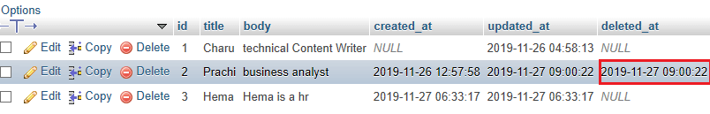
As we can observe from the above screenshot that the record of 'id' 2 is still available in the table, but a date is not null in the deleted_at column, which means that this record is soft-deleted.
- To delete the record permanently,
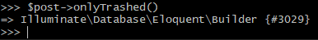
In the above screen, we use $post->onlyTrashed() means that the $post object contains only a trashed record.
To delete the trashed record permanently, we use the forceDelete() method on a $post object.
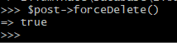
The above screen shows that the forceDelete() method returns a true value, which means that the record is successfully removed from the table.
Let's look at the database:

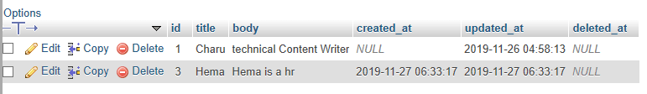
In the above screenshot, we observe that the record of 'id' 2 is deleted from the posts table.

Relationship with tinker
Till now, we find the relationship by using routes. Now, we will see the relationship through the tinker. In a laravel relationship topic, we read a one-to-one relationship with the help of the routes in which we find the post belonging to every user. Now, we find the post of every user in the tinker environment.
Let's understand through an example.
- First, we look at the data available in both the tables, users and posts table.
users table
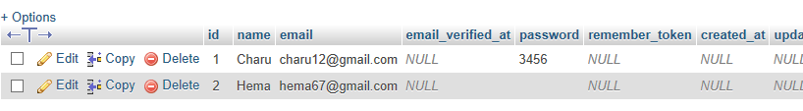
posts table
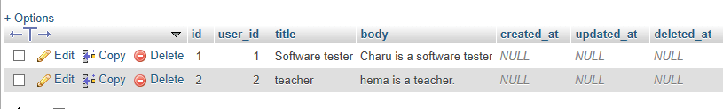
- In this step, we will find the user.
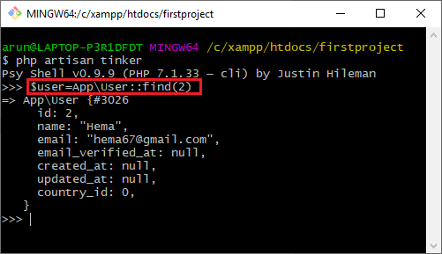
In the above screenshot, we observe that the $user object contains the second user, i.e., a record of 'id' equal to 2 in the 'users' table.
- Now, we implement the posts() method available in the User model through the $user object. The statement '$user->posts' calls the posts method of a User class.
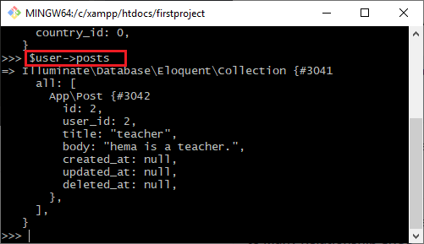
The above screen shows that the statement '$user->posts' retrieves the post of the user from the 'posts' table.
https://www.javatpoint.com/laravel-tinker

hp artisan tinker or php artisan ti
by using tinker command line we can create new user or insert new data in database

run php artisan ti

Psy Shell v0.10.6 (PHP 7.4.16 — cli) by Justin Hileman
>>> User::create(["name"=> "larainfo","email"=>"larainfo@gmail.com","password"=>bcrypt("123456")]);
=> App\Models\User {#4290
name: "larainfo",
email: "larainfo@gmail.com",
updated_at: "2021-04-22 08:23:28",
created_at: "2021-04-22 08:23:28",
id: 1,
}
>>>

or you can use different approaches to store new data let see

php artisan ti

>>> $user = new App\Models\User;
=> App\Models\User {#4301}
>>> $user->name = "larainfo";
=> "larainfo"
>>> $user->email= "larainfo@gmail.com";
=> "larainfo@gmail.com"
>>> $user->password=bcrypt('123456');
=> "$2y$10$uSdO/eBCQPNK3eVjXlSh.ulBVamZOhc.Hu5bp8Xzzb.uWyS3MSwRC"
>>> $user->save();
=> true
php artisan tinker
After Run this command
We have A mode for User.

>>> $user = new App\User
=> App\User {#3024}
>>> $user->name = 'CoderMen'
=> "CoderMen"
>>> $user->email = 'codermen@mail.com'
=> "codermen@mail.com"
>>> $user->password = bcrypt('password')
=> "$2y$10$GJCQzj71L56TDAG2wa3VNeSONgMWp8zAk2TQ1kfHVxPgARXg75fxO"
>>> $user->save()
=> true
>>>
https://www.codermen.com/how-to-use-tinker-to-store-data-in-database-in-laravel-6/

